ENGL 3110 - Exam One Study Guide - Spring 2026 — ANSWER KEY
This study guide mirrors the format and topics of Exam One. Use it to practice before the exam.
Sections:
- Section A: Multiple Choice — 13 questions
- Section B: Sentence Labeling and Diagramming — 5 sentences
- Bonus — 3 questions

Section A: Multiple Choice

Section A1: Morphology and Word Structure (Questions 1–4)
Question 1: How many morphemes does the word "unbreakable" contain?
Answer: c
a. 1
b. 2
c. 3 — un- (bound) + break (free) + -able (bound)
d. 4
Question 2: Which of the following words contains exactly one morpheme?
Answer: b
a. replay — 2 morphemes: re- + play
b. kitchen — 1 morpheme. It cannot be meaningfully divided into smaller units.
c. untrue — 2 morphemes: un- + true
d. singer — 2 morphemes: sing + -er
Question 3: Which of the following is a free morpheme?
Answer: c
a. -ly — bound morpheme (cannot stand alone)
b. -ment — bound morpheme (cannot stand alone)
c. tree — free morpheme (can stand alone as an independent word)
d. un- — bound morpheme (cannot stand alone)
Question 4: Which of the following correctly identifies the morphemes in "prewashing"?
Answer: a
a. pre- (bound) + wash (free) + -ing (bound) — Correct. pre- is a bound prefix meaning "before," wash is the free base, -ing is bound.
b. pre- (free) + wash (free) + -ing (bound) — Incorrect. pre- is bound, not free.
c. prewash (free) + -ing (bound) — Incorrect. prewash can be further divided.
d. pre- (bound) + washing (free) — Incorrect. washing should be divided into wash + -ing.

Section A2: Open and Closed Classes (Questions 5–8)
Question 5: Which of the following word classes is a closed class?
Answer: c
a. Verbs — open class
b. Nouns — open class
c. Pronouns — closed class (a fixed, limited set: I, you, he, she, it, we, they, etc.)
d. Adverbs — open class
Question 6: In the phrase "a small child in the classroom," which word is the head of the noun phrase?
Answer: c
a. a — determiner (modifier)
b. small — adjective (modifier)
c. child — The head noun. Cannot be removed without destroying the phrase.
d. classroom — head of a nested NP inside the PP, not the head of the main NP.
Question 7: "The artist displayed his paintings at the gallery." What is the antecedent of "his"?
Answer: b
a. The gallery
b. The artist — "his" (third person, singular, masculine) refers back to "The artist."
c. paintings
d. his paintings
Question 8: Which of the following words is NOT a preposition?
Answer: c
a. under — preposition
b. between — preposition
c. always — adverb (modifies verbs and describes frequency; does not introduce a PP)
d. beside — preposition

Section A3: Parts of Speech in Context (Questions 9–13)
Sentence for Questions 9–10: "Many eager volunteers cheerfully organized the annual fundraiser."
Question 9: Which word in the sentence above is a determiner?
Answer: b
a. eager — adjective
b. Many — determiner (indicates amount; cannot be modified by "very"; appears before adjectives)
c. cheerfully — adverb
d. annual — adjective
Question 10: Which word in the sentence above is an adverb?
Answer: c
a. Many — determiner
b. eager — adjective
c. cheerfully — adverb (modifies the verb "organized"; formed with -ly from cheerful)
d. fundraiser — noun
Question 11: "His brother quickly repaired our broken fence." Which word is functioning as a verb?
Answer: d
a. His — determiner
b. brother — noun
c. quickly — adverb
d. repaired — verb (the main action; takes past tense -ed)
Question 12: "Two curious puppies chased the red ball." Which word is an adjective?
Answer: b
a. Two — determiner
b. curious — adjective (describes a quality; can be modified by "very": very curious)
c. chased — verb
d. ball — noun
Question 13: In the phrase "the remarkably bright student," what word class does "remarkably" belong to?
Answer: b
a. Adjective
b. Adverb — "Remarkably" modifies the adjective "bright," telling the degree of brightness.
c. Determiner
d. Noun

Section B: Sentence Labeling and Diagramming
Instructions: For each sentence below, take two steps.
1. Complete the labeling table by filling in the Role, Phrase, and Part of Speech (POS) rows.
2. Write the bracket notation for the sentence's tree diagram.
Abbreviation Key
Parts of Speech | Phrase Types | Roles
Noun = N | Noun Phrase = NP | Subject = Subj
Verb = V | Verb Phrase = VP | Predicate = Pred
Adjective = ADJ
Adverb = ADV | Adjective Phrase = ADJP
Determiner = DET | Adverb Phrase = ADVP
Preposition = PREP | Prepositional Phrase = PP
 | Sentence = S
Notes:
- In the Phrase row, label the main verb as VP (Verb Phrase). The VP label in the table applies to just the main verb itself.
- In the Role row, label the subject noun phrase as Subject and the verb phrase as Predicate. Leave other role cells empty.
- Always include a phrase level for nouns, verbs, adjectives, adverbs, and prepositions.
Example: The old man sat quietly.
Role | Subject |  |  | Predicate
Phrase | NP |  |  | VP | ADVP
Word | The | old | man | sat | quietly
POS | DET | ADJ | N | V | ADV
Bracket notation: [S [NP [DET The] [ADJP [ADJ old]] [N man]] [VP [V sat] [ADVP [ADV quietly]]]]
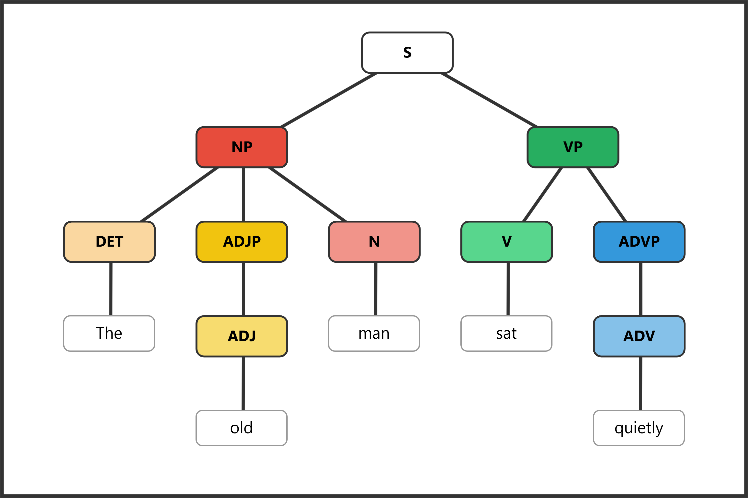

Question 14: The dog barked.
Role | Subject |  | Predicate
Phrase | NP |  | VP
Word | The | dog | barked
POS | DET | N | V
Bracket notation: [S [NP [DET The] [N dog]] [VP [V barked]]]
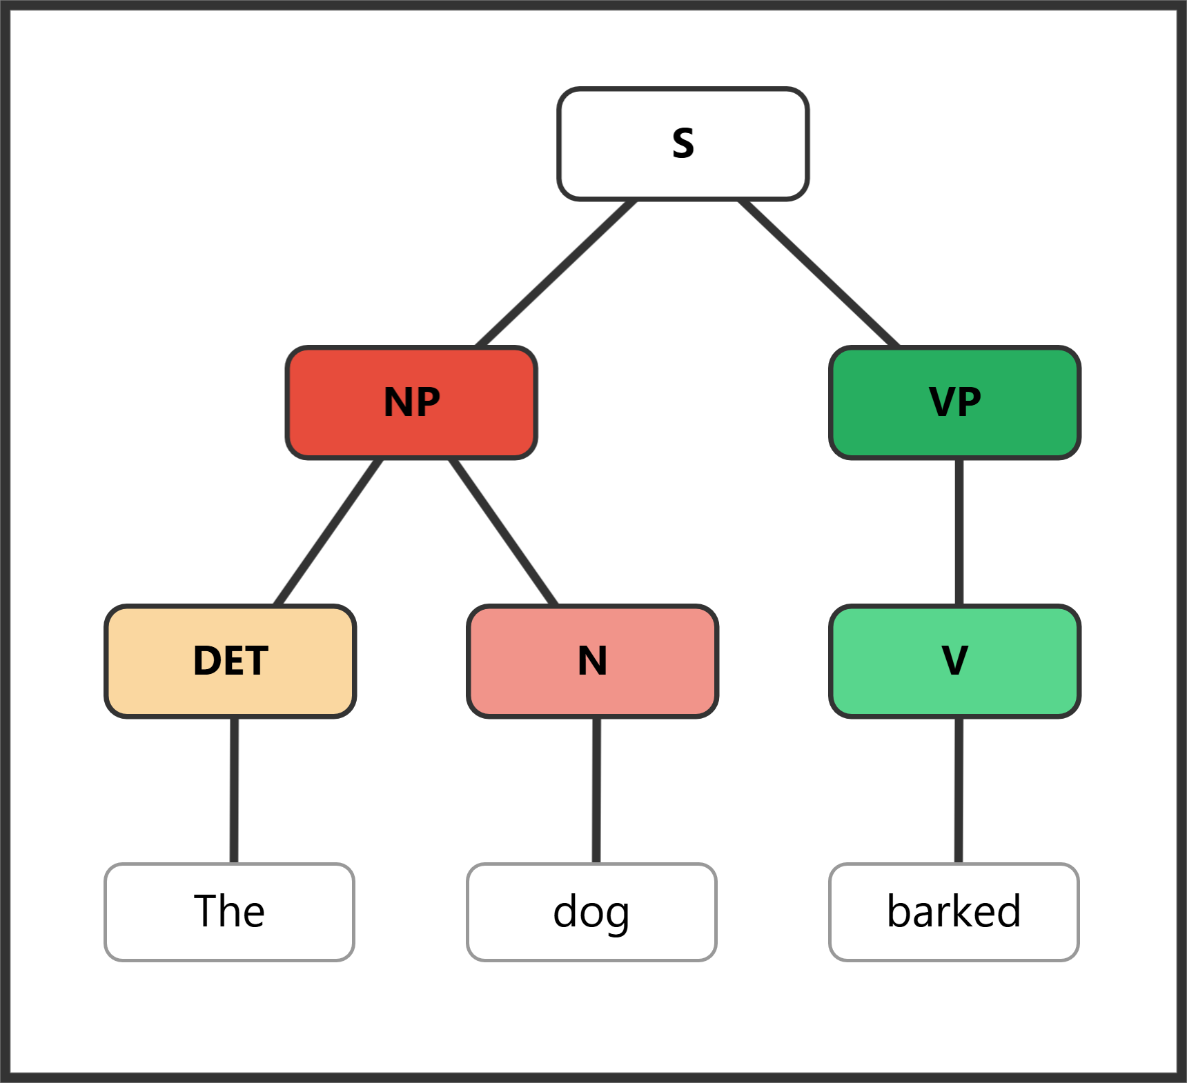

Question 15: The happy children played quietly in the park.
Role | Subject |  |  | Predicate
Phrase | NP |  |  | VP | ADVP | PP
Word | The | happy | children | played | quietly | in | the | park
POS | DET | ADJ | N | V | ADV | PREP | DET | N
Bracket notation: [S [NP [DET The] [ADJP [ADJ happy]] [N children]] [VP [V played] [ADVP [ADV quietly]] [PP [PREP in] [NP [DET the] [N park]]]]]
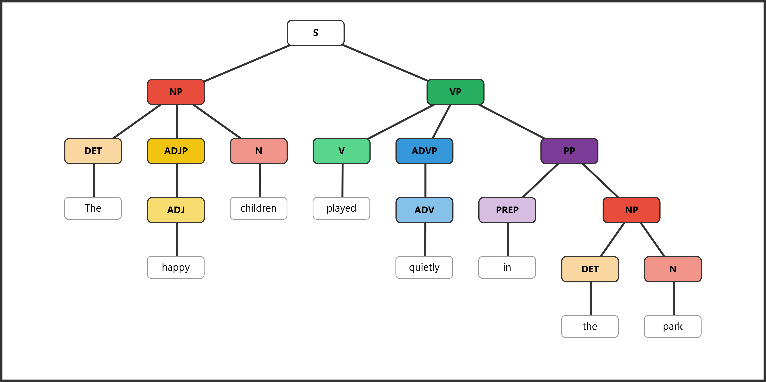

Question 16: The teacher from Texas arrived early.
Role | Subject |  |  |  | Predicate
Phrase | NP |  | PP |  | VP | ADVP
Word | The | teacher | from | Texas | arrived | early
POS | DET | N | PREP | N | V | ADV
Bracket notation: [S [NP [DET The] [N teacher] [PP [PREP from] [NP [N Texas]]]] [VP [V arrived] [ADVP [ADV early]]]]
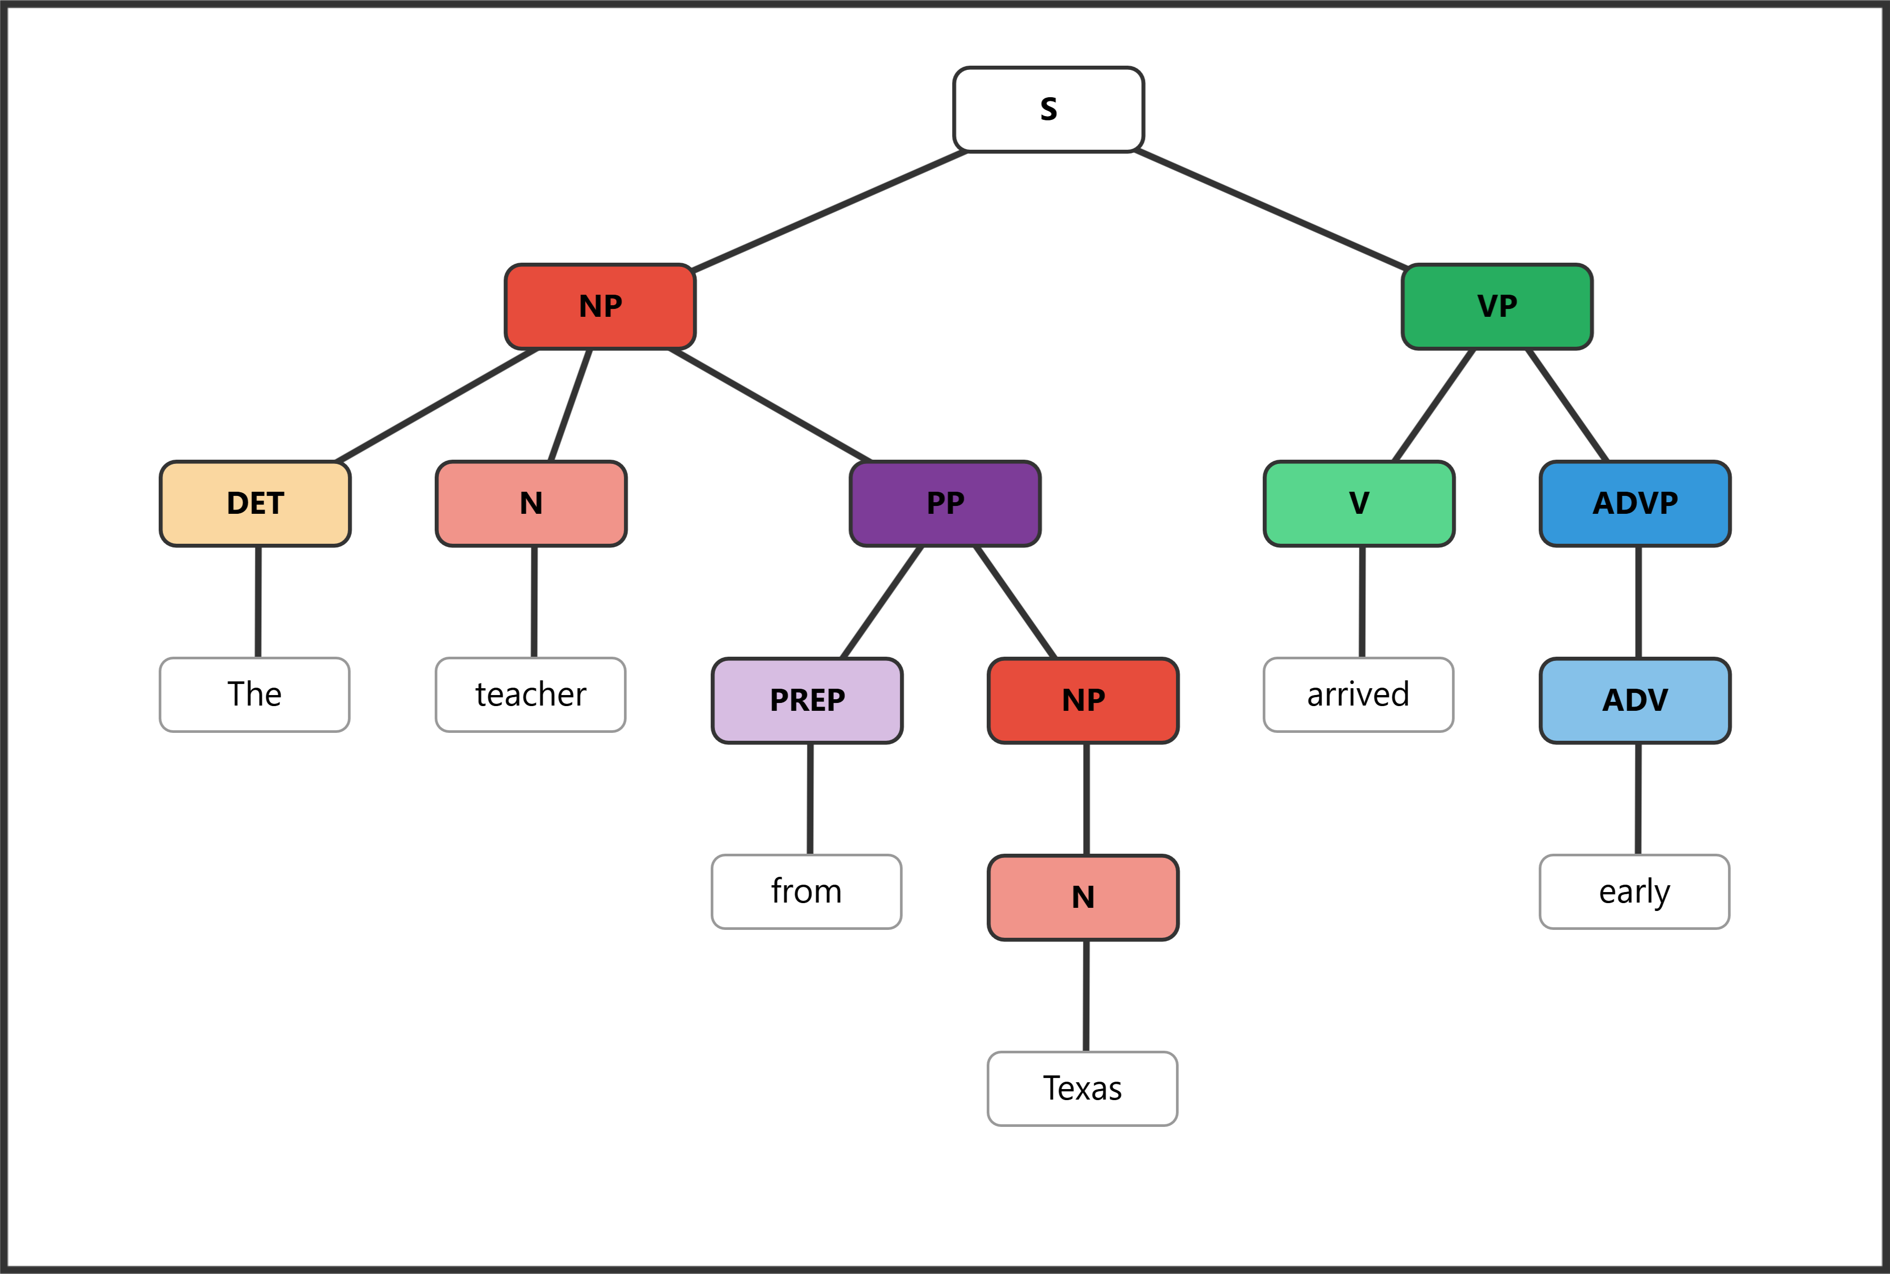

Question 17: Many talented musicians performed brilliantly during the annual festival.
Role | Subject |  |  | Predicate
Phrase | NP |  |  | VP | ADVP | PP
Word | Many | talented | musicians | performed | brilliantly | during | the | annual | festival
POS | DET | ADJ | N | V | ADV | PREP | DET | ADJ | N
Bracket notation: [S [NP [DET Many] [ADJP [ADJ talented]] [N musicians]] [VP [V performed] [ADVP [ADV brilliantly]] [PP [PREP during] [NP [DET the] [ADJP [ADJ annual]] [N festival]]]]]
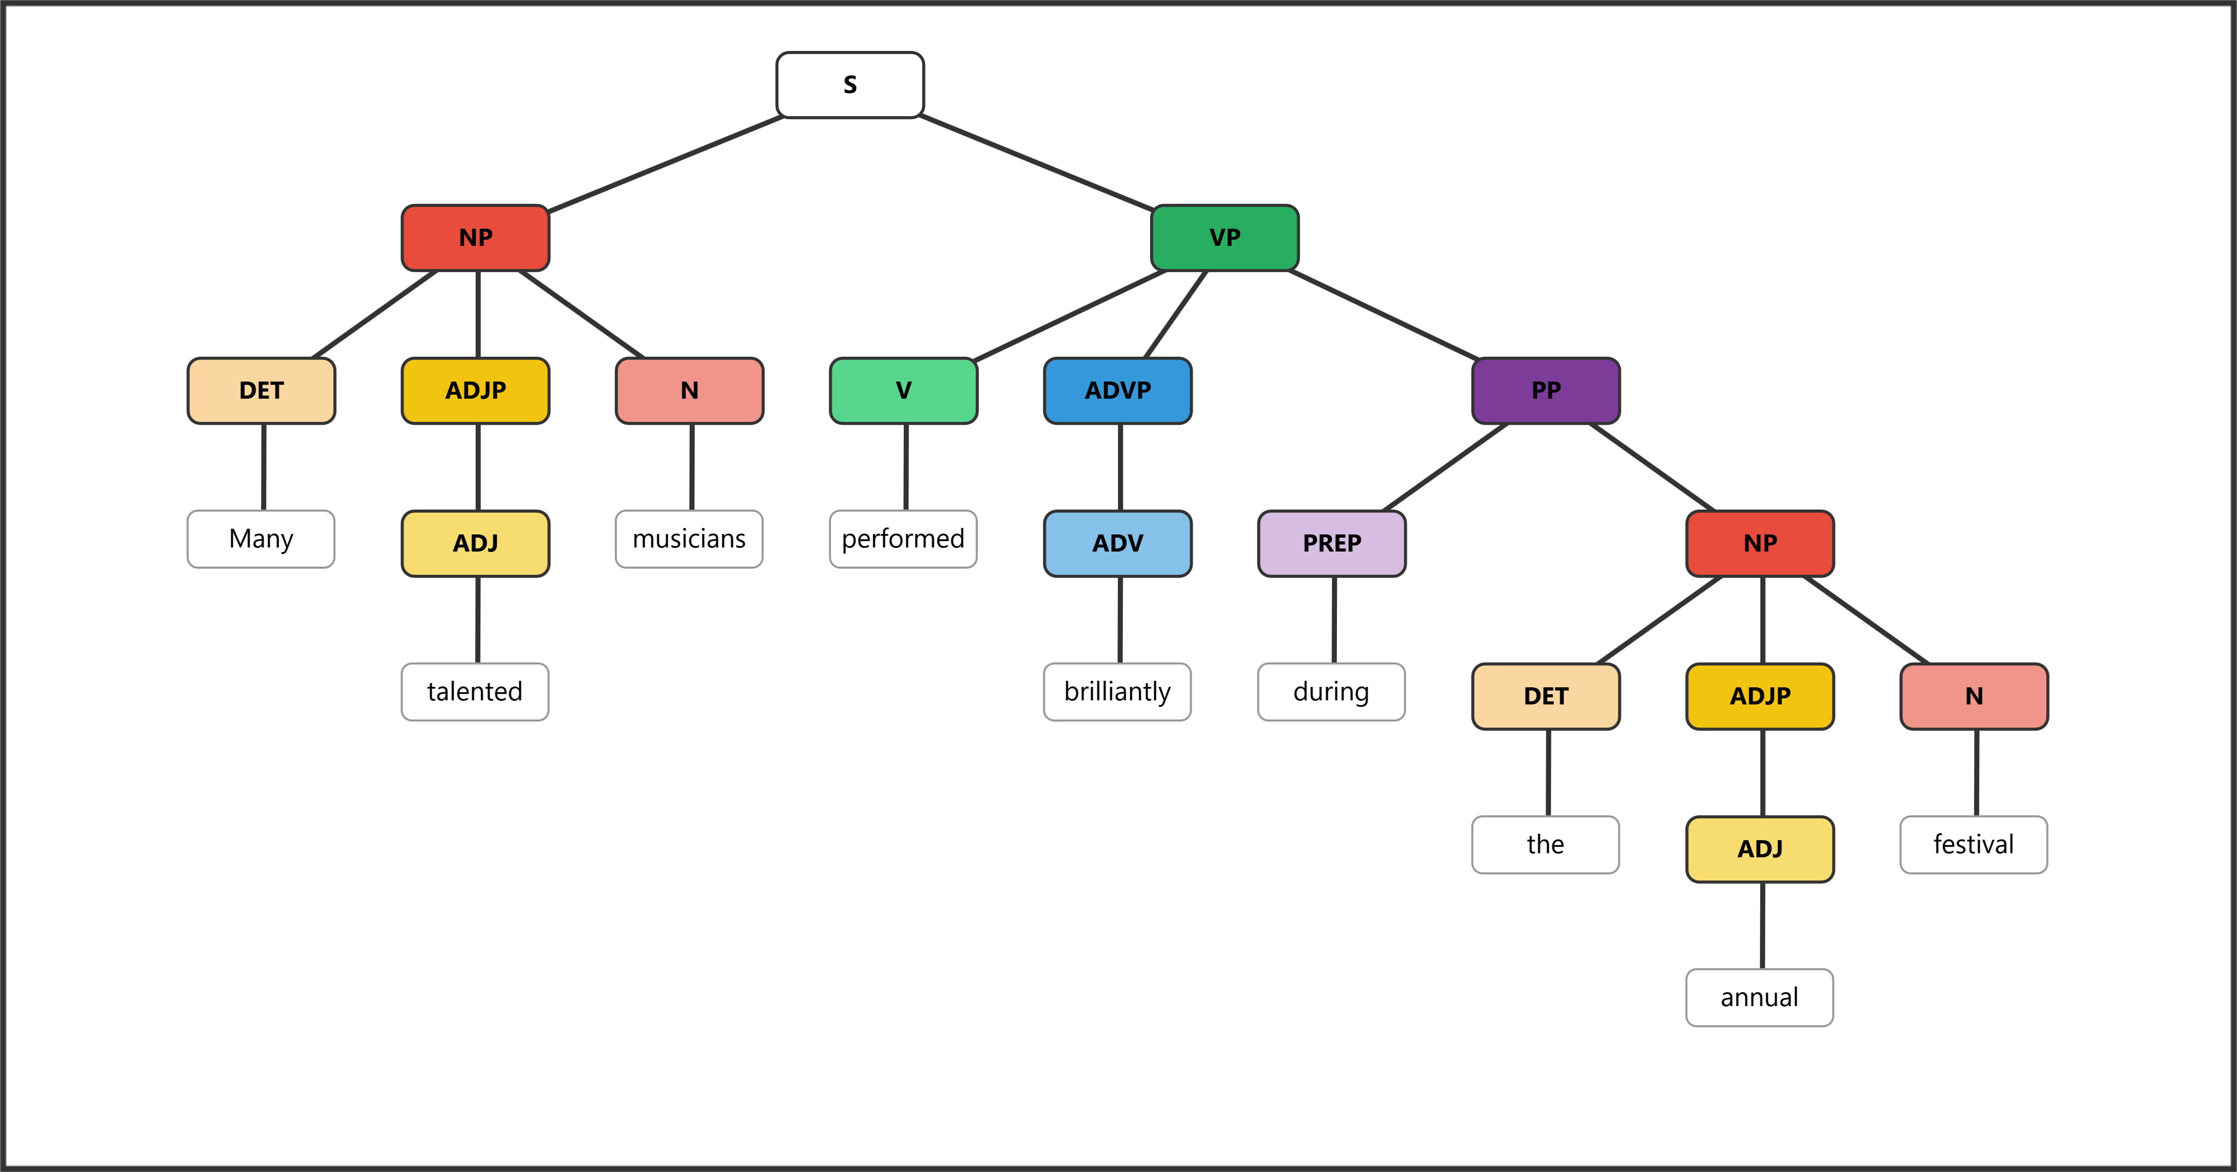

Question 18: The young artist with curly hair painted quite skillfully.
Role | Subject |  |  |  |  |  | Predicate
Phrase | NP |  |  | PP |  |  | VP | ADVP
Word | The | young | artist | with | curly | hair | painted | quite | skillfully
POS | DET | ADJ | N | PREP | ADJ | N | V | ADV | ADV
Bracket notation: [S [NP [DET The] [ADJP [ADJ young]] [N artist] [PP [PREP with] [NP [ADJP [ADJ curly]] [N hair]]]] [VP [V painted] [ADVP [ADVP [ADV quite]] [ADV skillfully]]]]
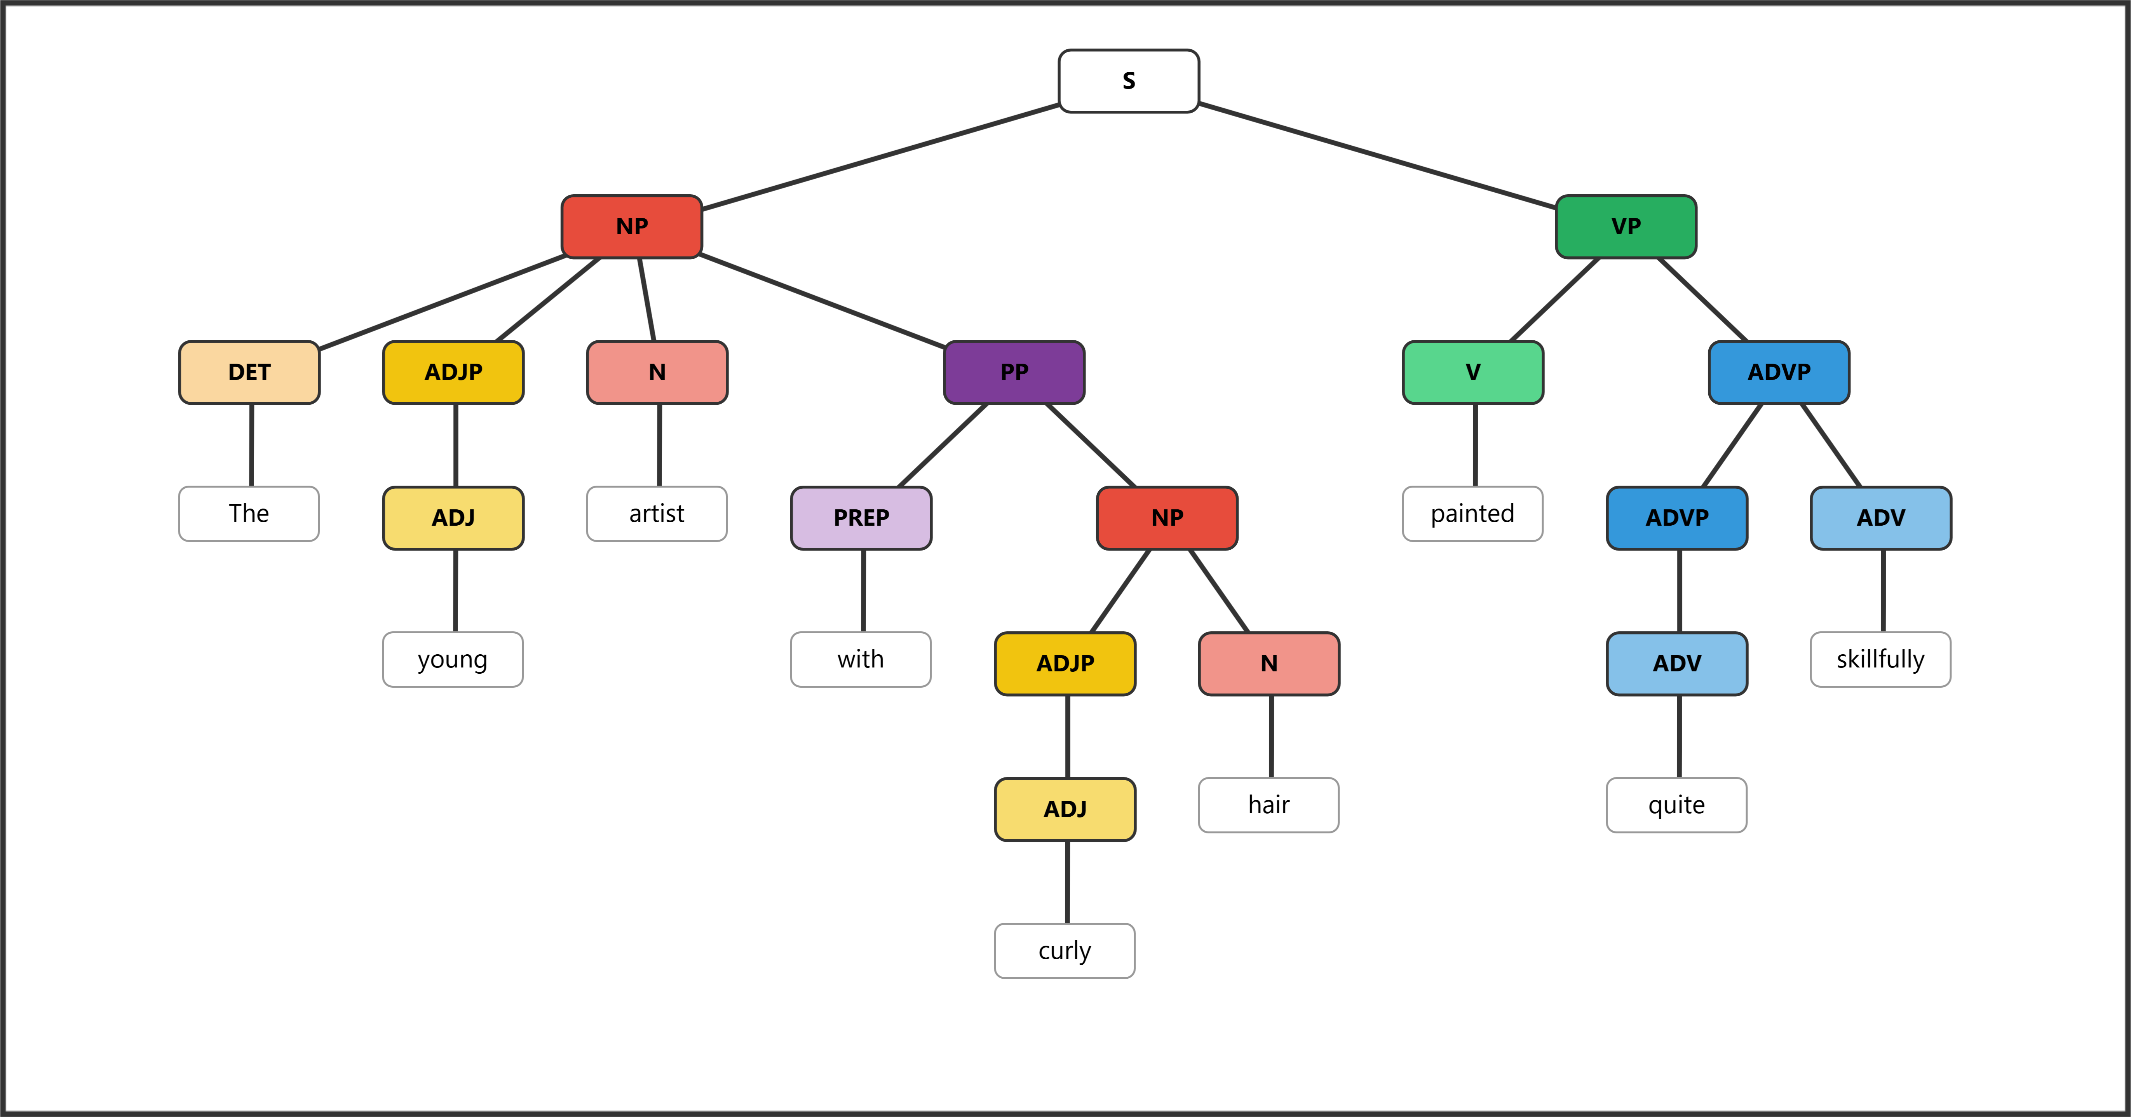

Bonus
Answers will vary. Accept any response that correctly demonstrates the required feature.
Bonus 1: Write a word that contains at least three morphemes. List each morpheme and label it as free or bound. (2 pts)
Example: "disagreeable" — dis- (bound) + agree (free) + -able (bound) = 3 morphemes
Award 1 pt for a valid word with 3+ morphemes and 1 pt for correct labeling.
Bonus 2: Write a noun phrase that contains a determiner, an adjective, and a noun. (2 pts)
Example: "the cheerful dog"
Award 1 pt for including all three elements and 1 pt for correct word class identification (DET + ADJ + N).
Bonus 3: Write a sentence containing a prepositional phrase that modifies a noun. Underline or circle the prepositional phrase. (2 pts)
Example: The book on the table belongs to me.
Award 1 pt for a valid sentence and 1 pt for correctly identifying a PP that modifies a noun (not a verb).

Quick Answer Reference
Question | Answer | Question | Answer
1 | c | 8 | c
2 | b | 9 | b
3 | c | 10 | c
4 | a | 11 | d
5 | c | 12 | b
6 | c | 13 | b
7 | b

